**PROJECT-1**



**By**

**G THARUN KUMAR**

**TYPE CASTING EXAMPLES IN JAVA**

**Program 1:**   **Byte Type Variable to Byte Type Variable Assignment**

class Demo{

public static void main(String []args)

{

byte a=36;

byte b;

b=a;

System.out.println(b);

}

}

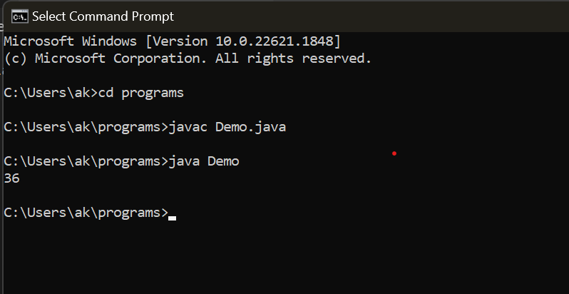

CONCLUSION: as byte and byte are compatible with each, no conversion is necessary.

**Program 2 : :**  **Byte Type Variable to short Variable Type Assignment**

class Demo2{

public static void main(String []args)

{

byte a=100;

short b;

b=a;

System.out.println(b);

}

}

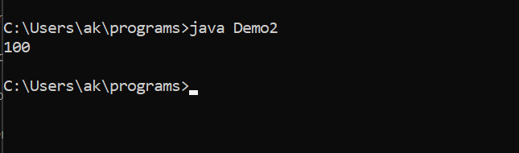

CONCLUSION: as byte and short are compatible with each other, and conversion happens implicitly .

**Program 3 : :**  **Byte Type Variable to int Type Variable Assignment**

class Demo3{

public static void main(String []args)

{

byte a=10;

int b;

b=a;

System.out.println(b);

}

}

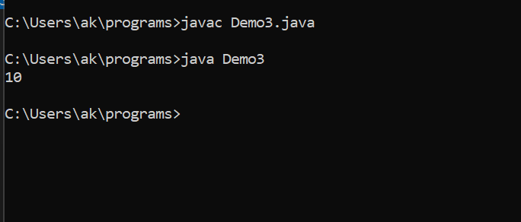

CONCLUSION: as byte and int are compatible with each other and conversion happens implicitly .

**Program 4 : :**  **Byte Type Variable to Long Type Variable Assignment**

class Demo4{

public static void main(String []args)

{

byte a=50;

long b;

b=a;

System.out.println(b);

}

}

CONCLUSION: as byte and long are compatible with each other and conversion happens implicitly (destination>source)

**Program 5 : :**  **Byte Type Variable to Float Type Variable Assignment**

class Demo5{

public static void main(String []args)

{

byte a=50;

float b;

b=a;

System.out.println(b);

}

}

CONCLUSION: as byte and float are compatible with each other and conversion happens implicitly (destination>source)

**Program 6 : :**  **Byte Type Variable to Double Type Variable Assignment**

class Demo6{

public static void main(String []args)

{

byte a=65;

double b;

b=a;

System.out.println(b);

}

}

CONCLUSION: as byte and double are compatible with each other and conversion happens implicitly (destination>source)

**Program 7 : :**  **Byte Type Variable to Character Type Variable Assignment**

class Demo7{

public static void main(String []args)

{

byte a=65;

char b;

b=(char)a;

System.out.println(b);

}

}

CONCLUSION:

class Demo8{

public static void main(String []args)

{

byte a=77;

boolean b;

b=(boolean)a;

System.out.println(b);

}

}

CONCLUSION: as byte and char are compatible with each other but conversion happens explicitly.

**Program 8 : :**  **Byte Type Variable to Boolean Type Variable Assignment**

class Demo9{

public static void main(String []args)

{

short s=-6;

byte b;

b=(byte)s;

System.out.println(b);

}

}

CONCLUSION: as byte and boolean are not compatible with each other.

**Program 9 : :**  **Short Type Variable to Byte Type Variable Assignment**

class Demo10{

public static void main(String []args)

{

short s=-6;

short b;

b=s;

System.out.println(b);

}

}

CONCLUSION: as short and byte are compatible, but conversion has to be done explicitly.

**Program 10 : :**  **Short Type Variable to Short Type Variable Assignment**

class Demo11{

public static void main(String []args)

{

short s=-6;

int b;

b=s;

System.out.println(b);

}

}

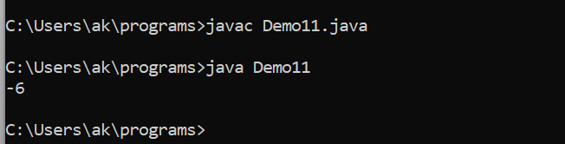

CONCLUSION: as short and short are compatible with each other, conversion is not necessary.

**Program 11 : :**  **Short Type Variable to Int Type Variable Assignment**

class Demo12{

public static void main(String []args)

{

short s=32767;

long b;

b=s;

System.out.println(b);

}

}

CONCLUSION: as short and int are compatible with each other, and conversion is peformed implicitly.

**Program 12 : :**  **Short Type Variable to Long Type Variable Assignment**

class Demo13{

public static void main(String []args)

{

short s=327;

float b;

b=s;

System.out.println(b);

}

}

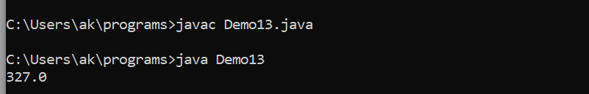

CONCLUSION: as short and Long are compatible with each other, and conversion is peformed implicitly.

**Program 13 : :**  **Short Type Variable to Float Type Variable Assignment**

class Demo14{

public static void main(String []args)

{

short s=3647;

double b;

b=s;

System.out.println(b);

}

}

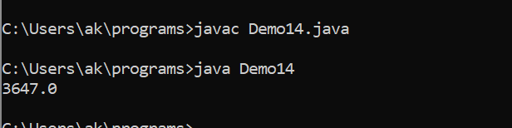

CONCLUSION: as short and float are compatible with each other, and conversion is peformed implicitly.

**Program 14 : :**  **Short Type Variable to Double Type Variable Assignment**

class Demo15{

public static void main(String []args)

{

short s=345;

char b;

b=(char)s;

System.out.println(b);

}

}

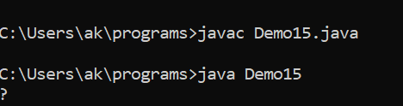

CONCLUSION: as short and float are compatible with each other, and conversion is peformed implicitly.

**Program 15 : :**  **Short Type Variable to Char Type Variable Assignment**

class Demo16{

public static void main(String []args)

{

short s=3465;

boolean b;

b=(boolean)s;

System.out.println(b);

}

}

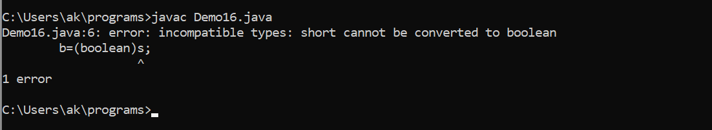

CONCLUSION: as short and char are compatible with each other, and but conversion is peformed explicitly.

**Program 16 : :**  **Short Type Variable to Boolean Type Variable Assignment**

class Demo17{

public static void main(String []args)

{

int i=99;

byte b;

b=(byte)i;

System.out.println(b);

}

}

CONCLUSION: as short and boolean are not compatible with each other.

**Program 17 : :**  **Int Type Variable to Byte Type Variable Assignment**

class Demo18{

public static void main(String []args)

{

int i=-7849;

short b;

b=(short)i;

System.out.println(b);

}

}

CONCLUSION: as Integer and Byte are compatible with each other, but conversion is done explicilty.

**Program 18 : :**  **Int Type Variable to Short Type Variable Assignment**

class Demo19{

public static void main(String []args)

{

int i=849;

int b;

b=i;

System.out.println(b);

}

}

CONCLUSION: as Integer and short are compatible with each other, but conversion is done explicilty.

**Program 19 : :**  **Int Type Variable to Integer Type Variable Assignment**

class Demo20{

public static void main(String []args)

{

int i=845649;

long b;

b=i;

System.out.println(b);

}

}

CONCLUSION: as Integer and Integer are compatible with each other, and conversion is not necessary.

**Program 20 : :**  **Int Type Variable to Long Type Variable Assignment**

class Demo21{

public static void main(String []args)

{

int i=8449;

float b;

b=i;

System.out.println(b);

}

}

CONCLUSION: as Integer and Long are compatible with each other, and conversion is done implicitly.

**Program 21 : :**  **Int Type Variable to Float Type Variable Assignment**

class Demo22{

public static void main(String []args)

{

int i=8465;

double b;

b=i;

System.out.println(b);

}

}

CONCLUSION: as Integer and Float are compatible with each other, and conversion is done implicitly.

**Program 22 : :**  **Int Type Variable to Double Type Variable Assignment**

class Demo23{

public static void main(String []args)

{

int i=8465;

char b;

b=(char)i;

System.out.println(b);

}

}

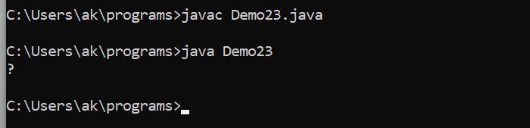

CONCLUSION: as Integer and Double are compatible with each other, and conversion is done implicitly.

**Program 23 : :**  **Int Type Variable to Character Type Variable Assignment**

class Demo24{

public static void main(String []args)

{

int i=8465;

boolean b;

b=(boolean)i;

System.out.println(b);

}

}

CONCLUSION: as Integer and char are compatible with each other, but conversion is done explicitly.

**Program 24 : :**  **Int Type Variable to Boolean Type Variable Assignment**

class Demo25

{

public static void main(String args[])

{

long l =67;

byte b;

b= (byte)l;

System.out.println(b);

}

}

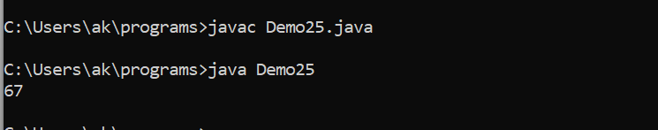

CONCLUSION: as Integer and boolean are not compatible with each other.

**Program 25 : :**  **Long Type Variable to Byte Type Variable Assignment**

class Demo26

{

public static void main(String args[])

{

long l =66;

short s;

s= (short)l;

System.out.println(s);

}

}

CONCLUSION: As Long and Byte are compatible with each other, but conversion is done explicitly.

**Program 26 : :**  **Long Type Variable to Short Type Variable Assignment**

class Demo27

{

public static void main(String args[])

{

long l =6785;

int i;

i= (int)l;

System.out.println(i);

}

}

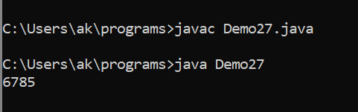

CONCLUSION: As Long and Short are compatible with each other, but conversion is done explicitly.

**Program 27 : :**  **Long Type Variable to Int Type Variable Assignment**

class Demo28

{

public static void main(String args[])

{

long l =685;

long e;

e= l;

System.out.println(e);

}

}

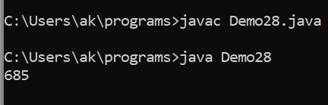

CONCLUSION: As Long and Int are compatible with each other, but conversion is done explicitly.

**Program 28 : :**  **Long Type Variable to Long Type Variable Assignment**

class Demo29

{

public static void main(String args[])

{

long l =4563 ;

float f;

f=l;

System.out.println(f);

}

}

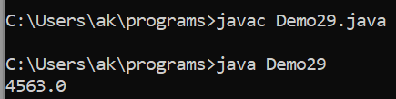

CONCLUSION: As Long and Long are compatible with each other, and conversion is not necessary.

**Program 29 : :**  **Long Type Variable to Float Type Variable Assignment**

class Demo30

{

public static void main(String args[])

{

long l =67654545;

double d;

d= (double)l;

System.out.println(d);

}

}

CONCLUSION: As Long and Float are compatible with each other, and conversion is explicitly done.

**Program 30 :**  **Long Type Variable to Double Type Variable Assignment**

class Demo31

{

public static void main(String args[])

{

long l =63 ;

char c;

c= (char)l;

System.out.println(c);

}

}

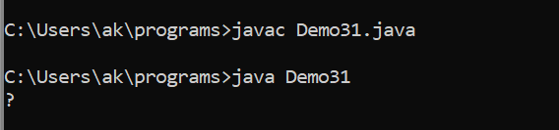

CONCLUSION: As Long and Double are compatible with each other, and conversion is explicitly done.

**Program 31 : :**  **Long Type Variable to Char Type Variable Assignment**

class Demo32

{

public static void main(String args[])

{

long l =6866456363 ;

boolean b;

b= (boolean)l;

System.out.println(b);

}

}

CONCLUSION: As Long and char are compatible with each other, and conversion is explicitly done.

**Program 32 : :**  **Long Type Variable to Boolean Type Variable Assignment**

class Demo33

{

public static void main(String args[])

{

float f = 3.14f;

byte b;

b= (byte)f;

System.out.println(b);

}

}

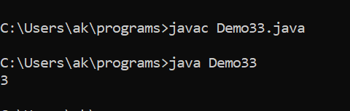

CONCLUSION: As Long and boolean are not compatible with each other.

**Program 33 : :**  **Float Type Variable to Byte Type Variable Assignment**

class Demo34

{

public static void main(String args[])

{

float f = 3.14f;

short s;

s= (short)f;

System.out.println(s);

}

}

CONCLUSION: As float and byte are compatible with each other, but conversion is done explicitly.

**Program 34 : :**  **Float Type Variable to Short Type Variable Assignment**

class Demo35

{

public static void main(String args[])

{

float f = 3.14f;

int i;

i= (int)f;

System.out.println(i);

}

}

CONCLUSION: As float and short are compatible with each other, but conversion is done explicitly.

**Program 35 : :**  **Float Type Variable to Int Type Variable Assignment**

class Demo36

{

public static void main(String args[])

{

float f = 5.14f;

long l;

l= (long) f;

System.out.println(l);

}

}

CONCLUSION: As float and int are compatible with each other, but conversion is done explicitly.

**Program 36 : :**  **Float Type Variable to Long Type Variable Assignment**

class Demo37

{

public static void main(String args[])

{

float f = 6.14f;

foat b;

b= f;

System.out.println(b);

}

}

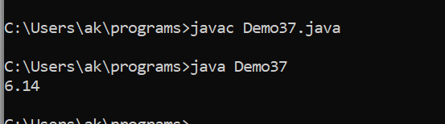

CONCLUSION: As float and long are compatible with each other, but conversion is done explicitly.

**Program 37 : :**  **Float Type Variable to Float Type Variable Assignment**

class Demo38

{

public static void main(String args[])

{

float f = 3.14f;

double d;

d = f;

System.out.println(d);

}

}

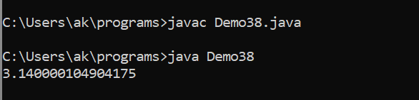

CONCLUSION: As float and float are compatible with each other, and conversion is not necessary.

**Program 39 : :**  **Float Type Variable to Char Type Variable Assignment**

class Demo39

{

public static void main(String args[])

{

float f = 3.14f;

char c;

c= (char) f;

System.out.println(c);

}

}

CONCLUSION: As float and char are compatible with each other, but conversion is done explicilty.

class Demo40

{

public static void main(String args[])

{

float f = 3.14f;

boolean b ;

b= (boolean) f;

System.out.println(b);

}

}

CONCLUSION:

**Program 40 : :**  **Float Type Variable to Boolean Type Variable Assignment**

class Demo41

{

public static void main(String args[])

{

double d = 24.7;

byte b;

b= (byte)d;

System.out.println(b);

}

}

CONCLUSION: As float and boolean are not compatible with each other.

**Program 41 : :**  **Double Type Variable to Byte Type Variable Assignment**

class Demo42

{

public static void main(String args[])

{

double d = 23.7654;

short s;

s= (short)d;

System.out.println(s);

}

}

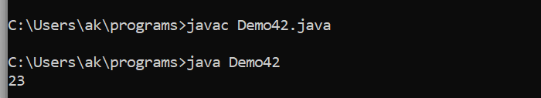

CONCLUSION: As double and byte are compatible with each other , but conversion is done explicitly.

**Program 42 : :**  **Double Type Variable to Byte Type Variable Assignment**

class Demo43

{

public static void main(String args[])

{

double d = 23.7654;

int i;

i = (int)d;

System.out.println(i);

}

}

CONCLUSION: As double and short are compatible with each other , but conversion is done explicitly.

**Program 43 : :**  **Double Type Variable to Int Type Variable Assignment**

class Demo43

{

public static void main(String args[])

{

double d = 23.7654;

int i;

i = (int)d;

System.out.println(i);

}

}

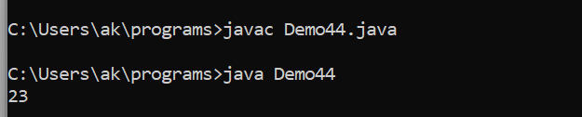

CONCLUSION: As double and int are compatible with each other , but conversion is done explicitly.

**Program 44 : :**  **Double Type Variable to Long Type Variable Assignment**

class Demo44

{

public static void main(String args[])

{

double d = 75.7654;

long l;

l = (long) d;

System.out.println(l);

}

}

CONCLUSION: As double and int are compatible with each other , but conversion is done explicitly.

**Program 45 : :**  **Double Type Variable to Float Type Variable Assignment**

class Demo45

{

public static void main(String args[])

{

double d = 12.7654;

float f;

f = (float)d;

System.out.println(f);

}

}

CONCLUSION: As double and float are compatible with each other , but conversion is done explicitly.

**Program 46 : :**  **Double Type Variable to Double Type Variable Assignment**

class Demo46

{

public static void main(String args[])

{

double d = 3.7654;

double f;

f = d;

System.out.println(f);

}

}

CONCLUSION:As double and double are compatible with each other , conversion is not necessary.

**Program 47 : :**  **Double Type Variable to char Type Variable Assignment**

class Demo47

{

public static void main(String args[])

{

double d = 343.7654;

char c;

c = (char) d;

System.out.println(c);

}

}

CONCLUSION:As double and char are compatible with each other , but explicit conversion is necessary.

**Conclusion ::** As double and char are compatible with each other , but explicit conversion is necessary.

class Demo48

{

public static void main(String args[])

{

double d = 23.7654;

boolean c;

c=(boolean)d;

System.out.println(c);

}

}

CONCLUSION: As double and boolean are not compatible with each other.

**Program 49 : :**  **Char Type Variable to Byte Type Variable Assignment**

class Demo49

{

public static void main(String args[])

{

char c = 'c';

byte b;

b = (byte)c;

System.out.println(b);

}

}

CONCLUSION:As char and byte are compatible with each other, but convesion is done explicitly.

**Program 50 : :**  **Char Type Variable to short Type Variable Assignment**

class Demo50

{

public static void main(String args[])

{

char c = 'c';

short s;

s = (short) c;

System.out.println(s);

}

}

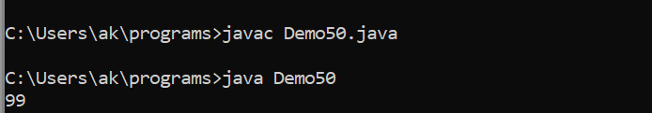

CONCLUSION:As char and short are compatible with each other, but convesion is done explicitly.

**Program 51 : :**  **Char Type Variable to Int Type Variable Assignment**

class Demo51

{

public static void main(String args[])

{

char c = 'c';

int i;

i = (int) c;

System.out.println(i);

}

}

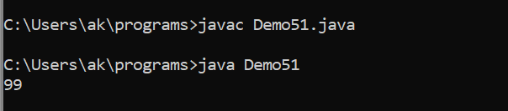

CONCLUSION: As char and int are compatible with each other, but conversion is done explicitly.

**Program 52 : :**  **Char Type Variable to Long Type Variable Assignment**

class Demo52

{

public static void main(String args[])

{

char c = 's';

long l;

l = (long) c;

System.out.println(l);

}

}

CONCLUSION: As char and long are compatible with each other, but conversion is done explicitly.

**Program 53 : :**  **Char Type Variable to float Type Variable Assignment**

class Demo53

{

public static void main(String args[])

{

char c = 'd';

float f;

f = (float) c;

System.out.println(f);

}

}

CONCLUSION: As char and float are compatible with each other, but conversion is done explicitly.

**Program 54 : :**  **Char Type Variable to Double Type Variable Assignment**

class Demo54

{

public static void main(String args[])

{

char c = 'c';

double d;

d = (double) c;

System.out.println(d);

}

}

CONCLUSION: As char and float are compatible with each other, but conversion is done explicitly.

**Program 55 : :**  **Char Type Variable to Char Type Variable Assignment**

class Demo55

{

public static void main(String args[])

{

char c = 'c';

char e;

e = c;

System.out.println(e);

}

}

CONCLUSION: As char and char are compatible with each other, and conversion is not necessary .

**Program 56 : :**  **Char Type Variable to boolean Type Variable Assignment**

class Demo56

{

public static void main(String args[])

{

char c = 'c';

boolean b;

b = (boolean)c;

System.out.println(b);

}

}

CONCLUSION: char and boolean are not compatible with each other.

**Program 57 : :**  **Boolean Type Variable to Byte Type Variable Assignment**

class Demo57

{

public static void main(String args[])

{

boolean b = true;

byte e;

e = (byte)b;

System.out.println(e);

}

}

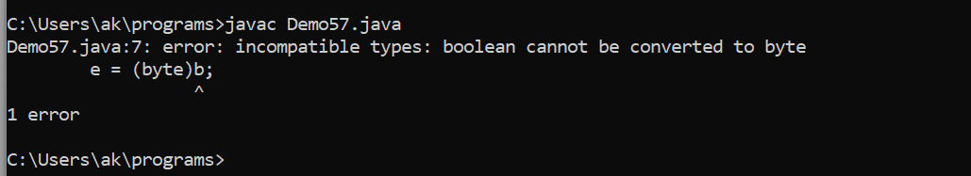

CONCLUSION: byte and boolean are not compatible with each other.

**Program 58 : :**  **Boolean Type Variable to short Type Variable Assignment**

class Demo58

{

public static void main(String args[])

{

boolean b = true;

short s;

s = (short)b;

System.out.println(s);

}

}

CONCLUSION: short and boolean are not compatible with each other.

**Program 59 : :**  **Boolean Type Variable to Int Type Variable Assignment**

class Demo59

{

public static void main(String args[])

{

boolean b = true;

int i;

i = (int)b;

System.out.println(i);

}

}

CONCLUSION: int and boolean are not compatible with each other.

**Program 60 : :**  **Boolean Type Variable to Long Type Variable Assignment**

class Demo60

{

public static void main(String args[])

{

boolean b = true;

long l;

l = (long)b;

System.out.println(l);

}

}

CONCLUSION: Long and boolean are not compatible with each other.

**Program 61 : :**  **Boolean Type Variable to Float Type Variable Assignment**

class Demo61

{

public static void main(String args[])

{

boolean b = true;

float f;

f = (float)b;

System.out.println(f);

}

}

CONCLUSION: Float and boolean are not compatible with each other.

**Program 62 : :**  **Boolean Type Variable to Double Type Variable Assignment**

class Demo62

{

public static void main(String args[])

{

boolean b = true;

double d;

d = (double)b;

System.out.println(d);

}

}

CONCLUSION: Double and boolean are not compatible with each other.

**Program 63 : :**  **Boolean Type Variable to char Type Variable Assignment**

class Demo63

{

public static void main(String args[])

{

boolean b = true;

char c;

c = (char)b;

System.out.println(c);

}

}

CONCLUSION: Char and boolean are not compatible with each other.

**Program 64 : :**  **Boolean Type Variable to Boolean Type Variable Assignment**

class Demo64

{

public static void main(String args[])

{

boolean b = true;

boolean e;

e = b;

System.out.println(e);

}

}

CONCLUSION: Boolean and Boolean are compatible with each other. Hence, conversion is not necessary.

|  |  |  |  |  |  |  |  |  |
| --- | --- | --- | --- | --- | --- | --- | --- | --- |
|  | byte | short | int | long | float | double | char | boolean |
| byte | - | Cast  (Implicit) | Cast  (Implicit) | Cast  (Implicit) | Cast  (Implicit) | Cast  (Implicit) | Cast  (Explicit) | No |
| short | Cast  (Explicit) | - | Cast  (Implicit) | Cast  (Implicit) | Cast  (Implicit) | Cast  (Implicit) | Cast  (Explicit) | No |
| int | Cast  (Explicit) | Cast  (Explicit) | - | Cast  (Implicit) | Cast  (Implicit) | Cast  (Implicit) | Cast  (Explicit) | No |
| long | Cast  (Explicit) | Cast  (Explicit) | Cast  (Explicit) | - | Cast  (Implicit) | Cast  (Implicit) | Cast  (Explicit) | No |
| float | Cast  (Explicit) | Cast  (Explicit) | Cast  (Explicit) | Cast  (Explicit) | - | Cast  (Implicit) | Cast  (Explicit) | No |
| double | Cast  (Explicit) | Cast  (Explicit) | Cast  (Explicit) | Cast  (Explicit) | Cast  (Explicit) | - | Cast  (Explicit) | No |
| char | Cast  (Explicit) | Cast  (Explicit) | Cast  (Implicit) | Cast  (Implicit) | Cast  (Implicit) | Cast  (Implicit) | - | No |
| boolean | No | No | No | No | No | No | No | - |

**Type casting Compatibitly table**